**University System Networking Project**

Albion University is a large university which has two campuses situated 20 miles apart. The university’s students and staff are distributed in 4 faculties; these include the faculties of Health and Sciences; Business; Engineering/Computing and Art/Design. Each member of staff has a PC and students have access to PCs in the labs. Create a network topology with the main components to support the following:

* **Main Campus**  
  **- Building A:** Administrative staff in the departments of management, HR and finance. The admin staff PCs are distributed in the building offices and it is expected that they will share some networking equipment (Hint: use of VLANs is expected here). The Faculty of Business is also situated in this building   
  **- Building B:** Faculty of Engineering and Computing and Faculty of Art and Design.   
  **- Building C:** Students’ labs and IT department. The IT department [hosts](https://gurutechnetworks.otombenard.com/assetsProject/project4) the University and other Servers

**-** There is also an email server hosted externally on the cloud.

* + **Smaller campus:**  
    - Faculty of Health and Sciences (staff and students’ labs are situated on separate floors)
* Each department/faculty is expected to be on its own separate IP network.
* The switches should be configured with appropriate VLANs and security settings.
* RIPv2 will be used to provide routing for the routers in the internal network and static routing for the external server.
* The devices in building A will be expected to acquire dynamic IP addresses from a router-based DHCP server.

Configure in Packet Tracer the network with appropriate settings to achieve the connectivity and functionalities specified in the requirements.

**Technologies Implemented**

1. Creating a network topology using Cisco Packet Tracer.
2. Hierarchical Network Design.
3. Connecting Networking devices with correct cabling.
4. Creating VLANs and assigning ports VLAN numbers.
5. Sub-netting and IP Addressing.
6. Configuring Inter-VLAN Routing (Router on a stick).
7. Configuring DHCP Server (Router as the DHCP Server).
8. Configuring SSH for secure Remote access.
9. Configuring RIPv2 as the routing protocol.
10. Configuring switch port security or Port-Security on the switches.
11. Host Device Configurations.
12. Test and Verifying Network Communication.

**Main Campus Router configuration (Turn on All Interfaces)**

Router>en

Router#conf t

Enter configuration commands, one per line. End with CNTL/Z.

Router(config)#int g0/0

Router(config-if)#no shut

Router(config-if)#

%LINK-5-CHANGED: Interface GigabitEthernet0/0, changed state to up

Router(config-if)#int s0/1/0

Router(config-if)#no shut

%LINK-5-CHANGED: Interface Serial0/1/0, changed state to down

Router(config-if)#int s0/1/1

Router(config-if)#no shut

%LINK-5-CHANGED: Interface Serial0/1/1, changed state to down

Router(config-if)#

**[NB- LAYER 3 SWITCHES MUST ON THE AC POWER SUPPLY]**

**Cloud Router configuration (Turn on All Interfaces)**

Router>en

Router#conf t

Enter configuration commands, one per line. End with CNTL/Z.

Router(config)#int g0/0

Router(config-if)#no shut

Router(config-if)#

%LINK-5-CHANGED: Interface GigabitEthernet0/0, changed state to up

%LINEPROTO-5-UPDOWN: Line protocol on Interface GigabitEthernet0/0, changed state to up

Router(config-if)#int s0/1/0

Router(config-if)#no shut

Router(config-if)#

%LINK-5-CHANGED: Interface Serial0/1/0, changed state to up

Router(config-if)#do wr

Building configuration...

[OK]

**Branch Router configuration (Turn on All Interfaces)**

Router>en

Router#conf t

Enter configuration commands, one per line. End with CNTL/Z.

Router(config)#int g0/0

Router(config-if)#no shut

Router(config-if)#

%LINK-5-CHANGED: Interface GigabitEthernet0/0, changed state to up

Router(config-if)#int s0/2/0

Router(config-if)#no shut

Router(config-if)#

%LINK-5-CHANGED: Interface Serial0/2/0, changed state to up

Router(config-if)#do wr

Building configuration...

[OK]

**Main Campus Router Clock Rate configure**

Router>en

Router#conf t

Enter configuration commands, one per line. End with CNTL/Z.

Router(config)#int s0/1/1

Router(config-if)#clock rate 64000

Router(config-if)#int s0/1/0

Router(config-if)#clock rate 64000

Router(config-if)#do wr

Building configuration...

[OK]

**MAIN CAMPUS ADMIN SWITCH**

Switch#conf t

Enter configuration commands, one per line. End with CNTL/Z.

Switch(config)#int range f0/1-24

Switch(config-if-range)#switchport mode access

Switch(config-if-range)#switchport access vlan 10

% Access VLAN does not exist. Creating vlan 10

Switch(config-if-range)#do wr

Building configuration...

[OK]

**[NB- SAME FOR ALL SWITHES BUT VLAN NUMBER IS CHANGE]**

**MAIN CAMPUS LAYER- 3 SWITCH**

Switch>en

Switch#conf t

Enter configuration commands, one per line. End with CNTL/Z.

Switch(config)#

%CDP-4-NATIVE_VLAN_MISMATCH: Native VLAN mismatch discovered on GigabitEthernet1/0/3 (1), with Switch FastEthernet0/1 (20).

Switch(config)#int g1/0/2

%CDP-4-NATIVE_VLAN_MISMATCH: Native VLAN mismatch discovered on GigabitEthernet1/0/2 (1), with Switch FastEthernet0/1 (10).

Switch(config-if)#switchport mode access

Switch(config-if)#switchport access vlan 10

% Access VLAN does not exist. Creating vlan 10

Switch(config-if)#do wr

Building configuration...

Compressed configuration from 7383 bytes to 3601 bytes[OK]

[OK]

**[DO THIS FOR ALL LAYER 2 SWITCHS, INTERFACES CHANGE]**

**ALL LAYER- 3 SWITCHES MUST BE TRUNK PORT**

Switch>en

Switch#conf t

Enter configuration commands, one per line. End with CNTL/Z.

Switch(config)#int g1/0/1

Switch(config-if)#switchport mode trunk

Switch(config-if)#

%LINEPROTO-5-UPDOWN: Line protocol on Interface GigabitEthernet1/0/1, changed state to down

%LINEPROTO-5-UPDOWN: Line protocol on Interface GigabitEthernet1/0/1, changed state to up

Switch(config-if)#do wr

Building configuration...

Compressed configuration from 7383 bytes to 3601 bytes[OK]

[OK]

**MAIN CAMPUS ROUTER**

Router>en

Router#conf t

Enter configuration commands, one per line. End with CNTL/Z.

Router(config)#int s0/1/1

Router(config-if)#ip add 10.10.10.1 255.255.255.252

Router(config-if)#int s0/1/0

Router(config-if)#ip add 10.10.10.5 255.255.255.252

Router(config-if)#do wr

Building configuration...

[OK]

**BREANCH ROUTER**

Router>en

Router#conf t

Enter configuration commands, one per line. End with CNTL/Z.

Router(config)#int s0/2/0

Router(config-if)#ip add 10.10.10.2 255.255.255.252

Router(config-if)#do wr

Building configuration...

[OK]

**CLOUD ROUTER**

Router>en

Router#conf t

Enter configuration commands, one per line. End with CNTL/Z.

Router(config)#int s0/1/0

Router(config-if)#ip add 10.10.10.6 255.255.255.252

Router(config-if)#int g0/0

Router(config-if)#ip add 20.0.0.1 255.255.255.252

Router(config-if)#do wr

Building configuration...

[OK]

**EMAIL SERVER CONFIGURATION**

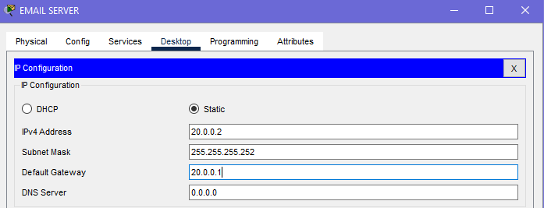

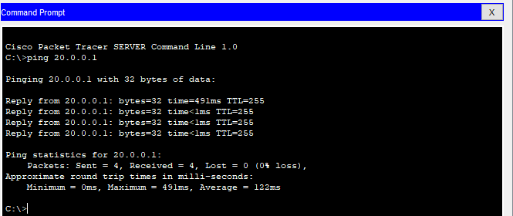

**Branch Router**

Router>en

Router#conf t

Enter configuration commands, one per line. End with CNTL/Z.

Router(config)#int g0/0.90

Router(config-subif)#encapsulation dot1q 90

Router(config-subif)#ip add 192.168.9.1 255.255.255.0

Router(config-subif)#int g0/0.100

Router(config-subif)#encapsulation dot1q 100

Router(config-subif)#ip add 192.168.10.1 255.255.255.0

Router(config-subif)#do wr

Building configuration...

[OK]

Router(config-subif)#ip dhcp pool staff-pool

Router(dhcp-config)#network 192.168.9.0 255.255.255.0

Router(dhcp-config)#default-route 192.168.9.1

Router(dhcp-config)#dns-server 192.168.9.1

Router(dhcp-config)#do wr

Router(dhcp-config)#exit

Router(config)#do wr

Building configuration...

[OK]

Router(config)#ip dhcp pool studentlab-pool

Router(dhcp-config)#network 192.168.10.0 255.255.255.0

Router(dhcp-config)#default-route 192.168.10.1

Router(dhcp-config)#dns-server 192.168.10.1

Router(dhcp-config)#exit

Router(config)#do wr

Building configuration...

[OK]

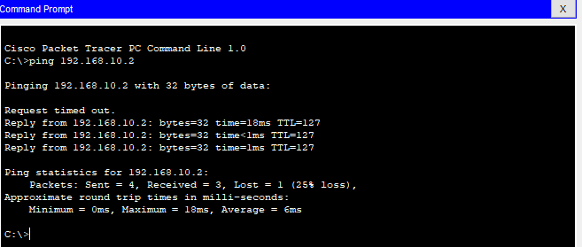

**MAIN CAMPUS ROUTER**

Router>en

Router#conf t

Enter configuration commands, one per line. End with CNTL/Z.

Router(config)#int g0/0.10

Router(config-subif)#

%LINK-5-CHANGED: Interface GigabitEthernet0/0.10, changed state to up

%LINEPROTO-5-UPDOWN: Line protocol on Interface GigabitEthernet0/0.10, changed state to up

Router(config-subif)#enca

Router(config-subif)#encapsulation dot1q 10

Router(config-subif)#ip add 192.168.1.1 255.255.255.0

Router(config-subif)#exit

Router(config)#int g0/0.20

Router(config-subif)#

%LINK-5-CHANGED: Interface GigabitEthernet0/0.20, changed state to up

%LINEPROTO-5-UPDOWN: Line protocol on Interface GigabitEthernet0/0.20, changed state to up

Router(config-subif)#encapsulation dot1q 20

Router(config-subif)#ip add 192.168.2.1 255.255.255.0

Router(config-subif)#exit

Router(config)#int g0/0.30

Router(config-subif)#

%LINK-5-CHANGED: Interface GigabitEthernet0/0.30, changed state to up

%LINEPROTO-5-UPDOWN: Line protocol on Interface GigabitEthernet0/0.30, changed state to up

Router(config-subif)#encapsulation dot1q 30

Router(config-subif)#ip add 192.168.3.1 255.255.255.0

Router(config-subif)#exit

Router(config)#int g0/0.40

Router(config-subif)#

%LINK-5-CHANGED: Interface GigabitEthernet0/0.40, changed state to up

%LINEPROTO-5-UPDOWN: Line protocol on Interface GigabitEthernet0/0.40, changed state to up

Router(config-subif)#encapsulation dot1q 40

Router(config-subif)#ip add 192.168.4.1 255.255.255.0

Router(config-subif)#exit

Router(config)#int g0/0.50

Router(config-subif)#

%LINK-5-CHANGED: Interface GigabitEthernet0/0.50, changed state to up

%LINEPROTO-5-UPDOWN: Line protocol on Interface GigabitEthernet0/0.50, changed state to up

Router(config-subif)#encapsulation dot1q 50

Router(config-subif)#ip add 192.168.5.1 255.255.255.0

Router(config-subif)#exit

Router(config)#int g0/0.60

Router(config-subif)#

%LINK-5-CHANGED: Interface GigabitEthernet0/0.60, changed state to up

%LINEPROTO-5-UPDOWN: Line protocol on Interface GigabitEthernet0/0.60, changed state to up

Router(config-subif)#encapsulation dot1q 60

Router(config-subif)#ip add 192.168.6.1 255.255.255.0

Router(config-subif)#exit

Router(config)#int g0/0.70

Router(config-subif)#

%LINK-5-CHANGED: Interface GigabitEthernet0/0.70, changed state to up

%LINEPROTO-5-UPDOWN: Line protocol on Interface GigabitEthernet0/0.70, changed state to up

Router(config-subif)#encapsulation dot1q 70

Router(config-subif)#ip add 192.168.7.1 255.255.255.0

Router(config-subif)#exit

Router(config)#int g0/0.80

Router(config-subif)#

%LINK-5-CHANGED: Interface GigabitEthernet0/0.80, changed state to up

%LINEPROTO-5-UPDOWN: Line protocol on Interface GigabitEthernet0/0.80, changed state to up

Router(config-subif)#encapsulation dot1q 80

Router(config-subif)#ip add 192.168.8.1 255.255.255.0

Router(config-subif)#exit

Router(config)#do wr

Building configuration...

[OK]

Router(config)#

Router(config)#service dhcp

Router(config)#ip dhcp pool admin-pool

Router(dhcp-config)#network 192.168.1.0 255.255.255.0

Router(dhcp-config)#default-router 192.168.1.1

Router(dhcp-config)#dns-server 192.168.1.1

Router(dhcp-config)#exit

Router(config)#ip dhcp pool hr-pool

Router(dhcp-config)#network 192.168.2.0 255.255.255.0

Router(dhcp-config)#default-router 192.168.2.1

Router(dhcp-config)#dns-server 192.168.2.1

Router(dhcp-config)#exit

Router(config)#ip dhcp pool finance-pool

Router(dhcp-config)#network 192.168.3.0 255.255.255.0

Router(dhcp-config)#default-router 192.168.3.1

Router(dhcp-config)#dns-server 192.168.3.1

Router(dhcp-config)#exit

Router(config)#ip dhcp pool business-pool

Router(dhcp-config)#network 192.168.4.0 255.255.255.0

Router(dhcp-config)#default-router 192.168.4.1

Router(dhcp-config)#dns-server 192.168.4.1

Router(dhcp-config)#exit

Router(config)#ip dhcp pool engineer-pool

Router(dhcp-config)#network 192.168.5.0 255.255.255.0

Router(dhcp-config)#default-router 192.168.5.1

Router(dhcp-config)#dns-server 192.168.5.1

Router(dhcp-config)#exit

Router(config)#ip dhcp pool artdesign-pool

Router(dhcp-config)#network 192.168.6.0 255.255.255.0

Router(dhcp-config)#default-router 192.168.6.1

Router(dhcp-config)#dns-server 192.168.6.1

Router(dhcp-config)#ip dhcp pool studentlab-pool

Router(dhcp-config)#network 192.168.7.0 255.255.255.0

Router(dhcp-config)#default-router 192.168.7.1

Router(dhcp-config)#dns-server 192.168.7.1

Router(dhcp-config)#exit

Router(config)#ip dhcp pool it-pool

Router(dhcp-config)#network 192.168.8.0 255.255.255.0

Router(dhcp-config)#default-router 192.168.8.1

Router(dhcp-config)#dns-server 192.168.8.1

Router(dhcp-config)#exit

Router(config)#do wr

Building configuration...

[OK]

Router(config)#

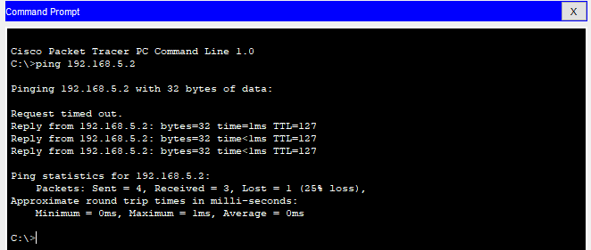

**BRANCH ROUTER RIP CONFIGURATION**

Router>en

Router#conf t

Enter configuration commands, one per line. End with CNTL/Z.

Router(config)#router rip

Router(config-router)#version 2

Router(config-router)#network 192.168.9.0

Router(config-router)#network 192.168.10.0

Router(config-router)#network 10.10.10.0

Router(config-router)#exit

Router(config)#do wr

Building configuration...

[OK]

**MAIN CAMPUS ROUTER RIP CONFIG**

Router>en

Router#conf t

Enter configuration commands, one per line. End with CNTL/Z.

Router(config)#router rip

Router(config-router)#version 2

Router(config-router)#network 10.10.10.0

Router(config-router)#network 10.10.10.4

Router(config-router)#network 192.168.1.0

Router(config-router)#network 192.168.2.0

Router(config-router)#network 192.168.3.0

Router(config-router)#network 192.168.4.0

Router(config-router)#network 192.168.5.0

Router(config-router)#network 192.168.6.0

Router(config-router)#network 192.168.7.0

Router(config-router)#network 192.168.8.0

Router(config-router)#exit

Router(config)#do wr

Building configuration...

[OK]

**CLOUD ROUTER RIP CONFIG**

Router>en

Router#conf t

Enter configuration commands, one per line. End with CNTL/Z.

Router(config)#router rip

Router(config-router)#version 2

Router(config-router)#network 20.0.0.0

Router(config-router)#network 10.10.10.4

Router(config-router)#exit

Router(config)#do wr

Building configuration...

[OK]

